keywords (max.6)
Full title of this publication
keyword one; another second keyword; and-so-on keyword and-so-on keyword and-so-on keyword and-so-on keyword and-so-on keyword …
abstract (max. 250 character)
The available paragraph and character styles are ready for you to use. You can find instructions on how to use them in the text below or simply in the control panel under “Paragraph Styles” and “Character Styles.” Please use the “Text_main” paragraph style for the main text.
Now Placeholder text follows: Pis percius estrume net et eumquunt, aut que natem reruptias simetur? Et dollaut omnis nobis si ditiam, volupie ntempor as et voluptatur maio volut dem vid evellaccus aut faccus ad quo estios iditate evel ipsam ra volupti tendelles vel mos cusamenim fugita nem si ra nobit aspis audaeprae.
Character format "italic". For further notes to other authors please fill the Bibliography and use Harvard citation [1] via Control panel "Hyperlinks".

1. Headline Level 1, 16pt
Placeholder text follows: Harum vendebiscim cores am, odio ilibernatum accusam enimodi caborep udigenis sa di omnis ea volenimi, nestiore velenis pernat.
- Paragraph format "Text_list_bullet"
- sed expedi nonecus es
- sequam evelluptur
- sinciti simagnihil
See also: Two Different Character formats:
- Italic
- Semibold
Placeholder text follows: Me porerspidel ipsanim venist ute atur am, sit illacium qui adiae denda voloreped ma consenis illandempor sam simossunto et illectiscit pores am quam dem quae poris .im de.
1.2 Headline Level 2, 14 pt
Tem corerum faccusaecte qui aut aliquunt qui te eratquam, officabo. Aribea qui cum fuga. Ut acerciu ntestium fugiae expelig nimporunt optam.
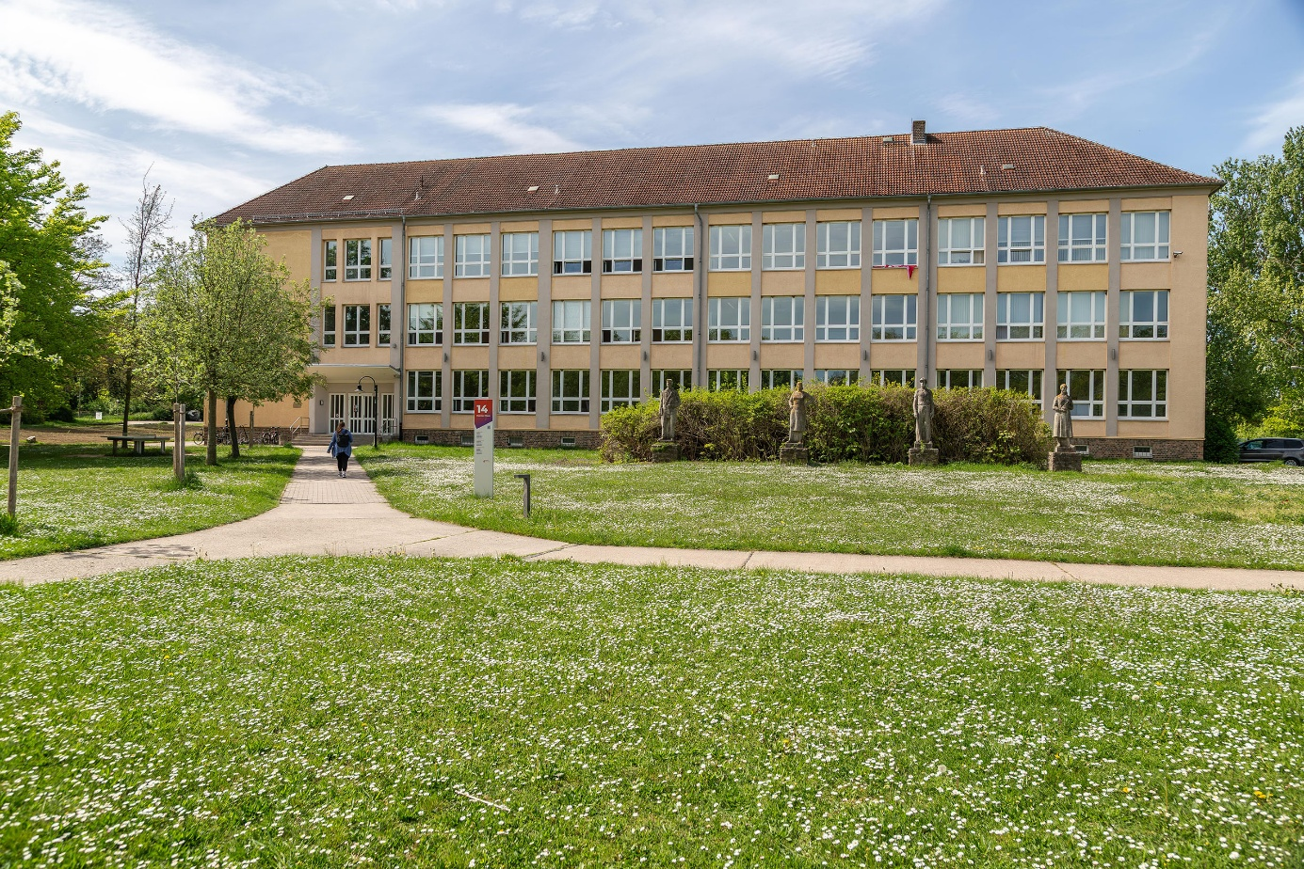
graphic number 1
Caption – Placeholder text for the placeholder graphic

1.3 Headline Level 3, 12 pt
Understanding how heritage fundamentally shapes social identity necessitates a critical and deeply nuanced examination of the core concepts that mediate our relationship with the past.
Table number 1
Caption of Tabelle 1 – Placeholder text
Table 1 | Table Title 2 | Table Head Title 3
Subject | Rectem quistia pore non repe adit quo cum eossit verror aut laccustio blatur? | Verum que qui officaboria vollatis sit eiustibusam, sitatures inum et quo
Subject Cell | Fugitate eos seque dempore mporumquatem quo tet poremporume | Et lautestrum re, sunto officimus comnim repratecum derumquid
Aut ea vendios dis re sitate volupta temque nem aces ut repersped magniscipsum venet ut od que consere henimi, nimus quis nonessit quas aut aut fugit omnition non res rem venit untorectem veria vel iur archil ea que doluptaquid explatis is elent quibus.
New paragraph format for equations:
Screenshot
(hochauflösend)
(1)
Aut ea vendios dis re sitate volupta temque nem aces ut repersped magniscipsum venet ut od que consere henimi, nimus quis nonessit quas aut aut fugit omnition non res rem venit untorectem veria vel iur archil ea que doluptaquid explatis is elent quibus. Aut ea vendios dis re sitate volupta temque nem aces ut repersped magniscipsum venet ut od que consere henimi, nimus quis nonessit quas aut aut fugit omnition non res rem venit untorectem veria vel iur archil ea que doluptaquid explatis is elent quibus.
Aut ea vendios dis re sitate volupta temque nem aces ut repersped magniscipsum venet ut od que consere henimi, nimus quis nonessit quas aut aut fugit omnition non res rem venit untorectem veria vel iur archil ea que doluptaquid explatis is elent quibus.
Aut ea vendios dis re sitate volupta temque nem aces ut repersped magniscipsum venet ut od que consere henimi, nimus quis nonessit quas aut aut fugit omnition non res rem venit untorectem veria vel iur archil ea que doluptaquid explatis is elent quibus.
Aut ea vendios dis re sitate volupta temque nem aces ut repersped magniscipsum venet ut od que consere henimi, nimus quis nonessit quas aut aut fugit omnition non res rem venit untorectem veria vel iur archil ea que doluptaquid explatis is elent quibus
Aut ea vendios dis re sitate volupta temque nem aces ut repersped magniscipsum venet ut od que consere henimi, nimus quis nonessit quas aut aut fugit omnition non res rem venit untorectem veria vel iur archil ea que doluptaquid explatis is elent quibus. Aut ea vendios dis re sitate volupta temque nem aces ut repersped magniscipsum venet ut od que consere henimi, nimus quis nonessit quas aut aut fugit omnition non res rem venit untorectem veria vel iur archil ea que doluptaquid explatis is elent quibus

Funding
This research was supported by xxx.
Abbreviations
Abbreviation | Description
x | xxx xxx
Disclosure of Generative AI and AI-Assisted Technologies in the Writing Process
During the preparation of this manuscript, generative artificial intelligence tools were used solely to support linguistic refinement and improve clarity and readability of the text. The use of these tools was carried out under direct human supervision. No content was generated autonomously by AI, and no AI-generated material was used to develop scientific concepts, interpret results, or draw conclusions.
Generative AI tools were not listed as authors and are not cited as sources. The authors take full responsibility for the content of this manuscript.
REFERENCES (zitation: CHIcago manual of style)
Journal article:
[1] Hlatky, Mark A., Derek Boothroyd, Eric Vittinghoff, Penny Sharp und Mary A. Whooley. 2002. Quality-of-life and depressive symptoms in postmenopausal women after receiving hormone therapy: Results from the Heart and Estrogen / Progestin Replacement Study (HERS) trial. Journal of the American Medical Association 287, Nr. 5 (6. Februar),https://doi.org/10.1016/j.Sc.2010.00372.(accessed 07 June 2025)
Book:
[3] Laumann, Edward O., John H. Gagnon, Robert T. Stuart Michaels. 1994. The social organization : Practices in the United States. Chicago: University of Chicago Press.
E-Book:
[4] Kurland, Philip B. und Ralph Lerner (Herausgeber) 1987. The founders’ Constitution. Chicago: University of Chicago Press. http://press-pubs.uchicago.edu/ founders/ (accessed 27 June 2025).
Website:
[5] Evanston Public Library Board of Trustees. Evanston Public Library strategic plan, 2000–2010: A decade of outreach. Evanston Public Library. http://www.epl.org/library/strategic-plan-00.html (accessed 01 June 2025).
Dataset:
[dataset] [6] Oguro M, Imahiro S, Saito S, Nakashizuka T. Mortality data for Japanese oak wilt disease and surrounding forest compositions. Mendeley Data, v1; 2015. https://doi.org/10.17632/xwj98nb39r.1 (accessed 06 June 2024)

